# What are convolutions and pooling?

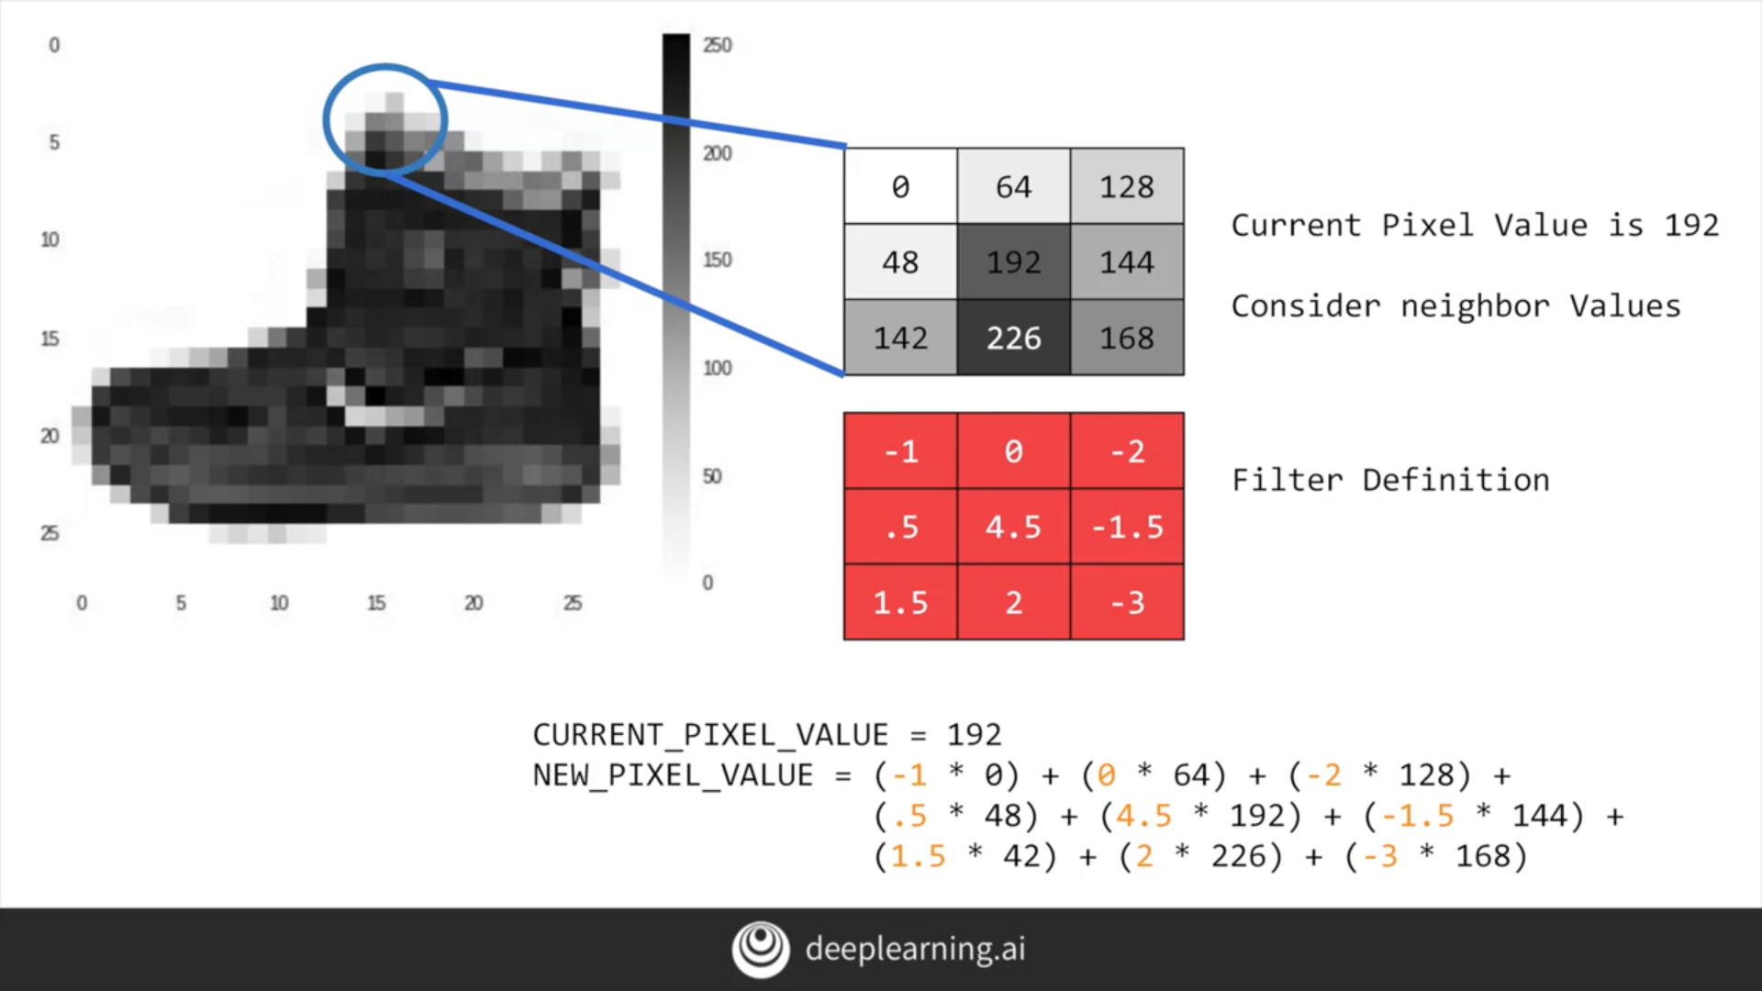

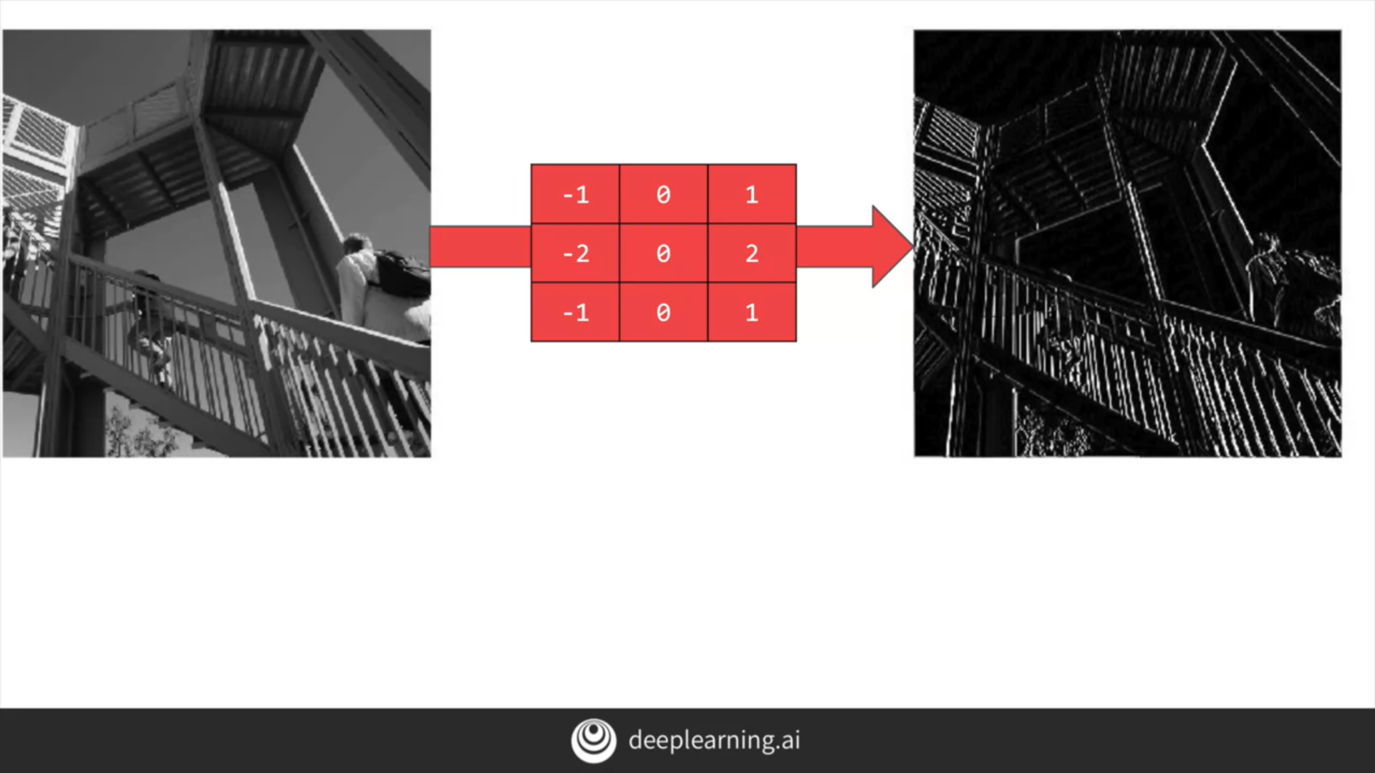

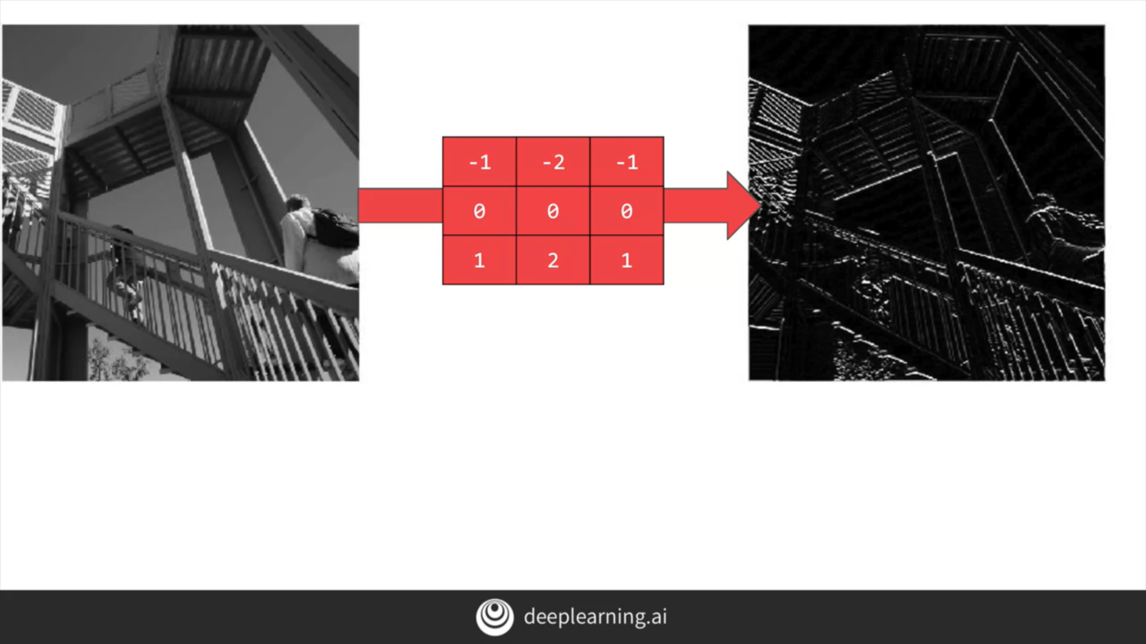

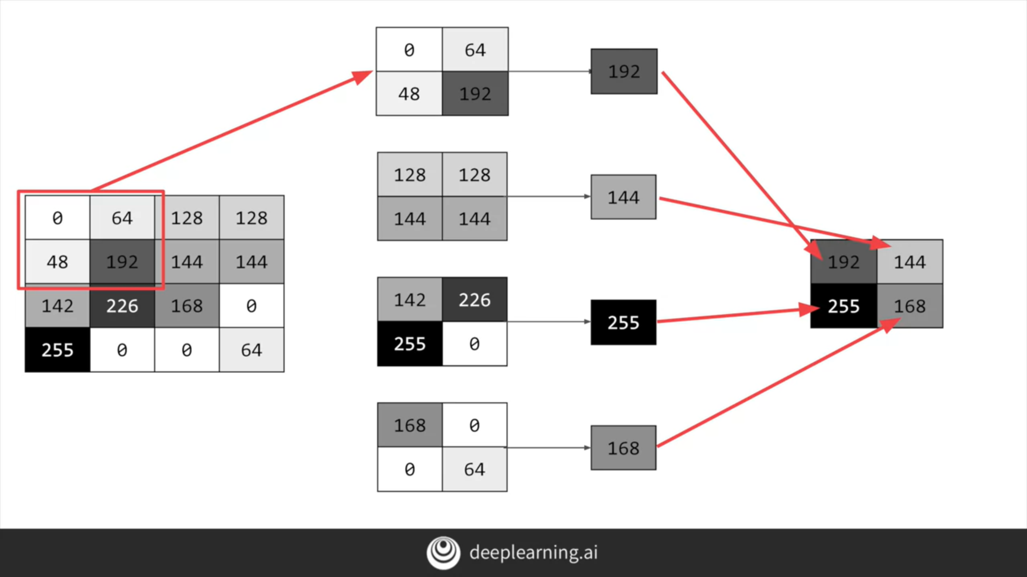

# Implementing convolutional and pooling layers

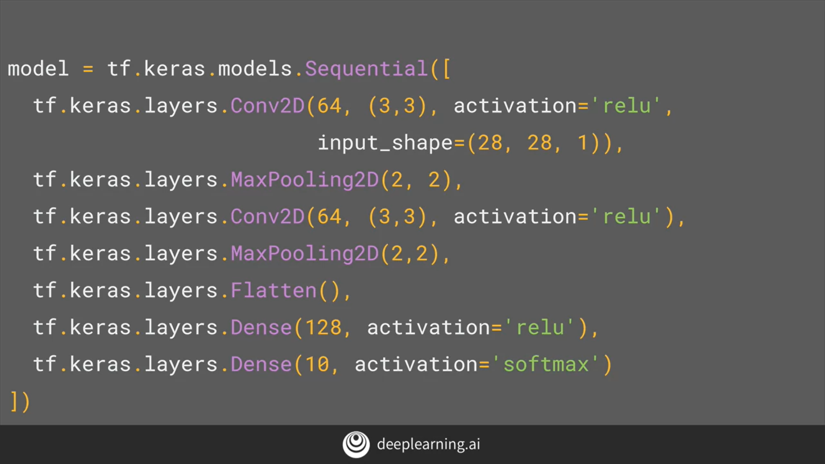

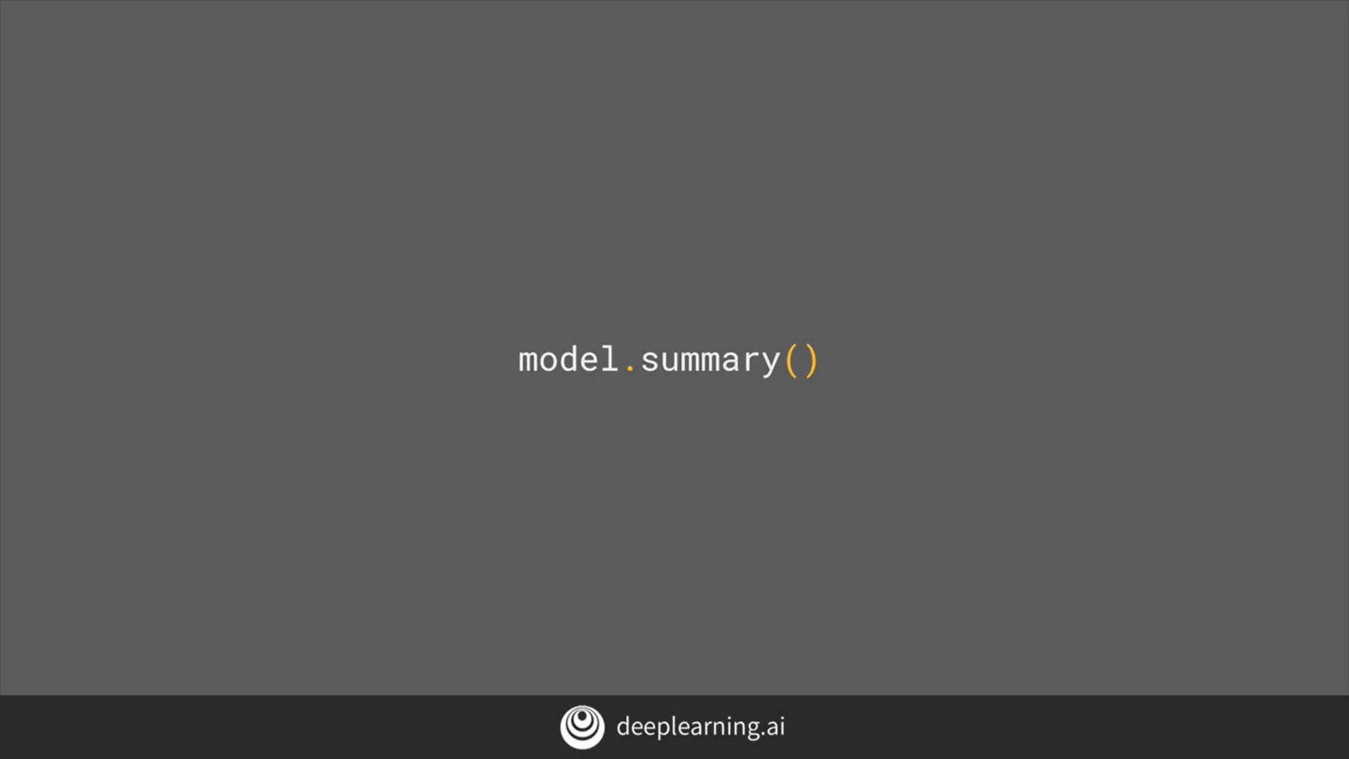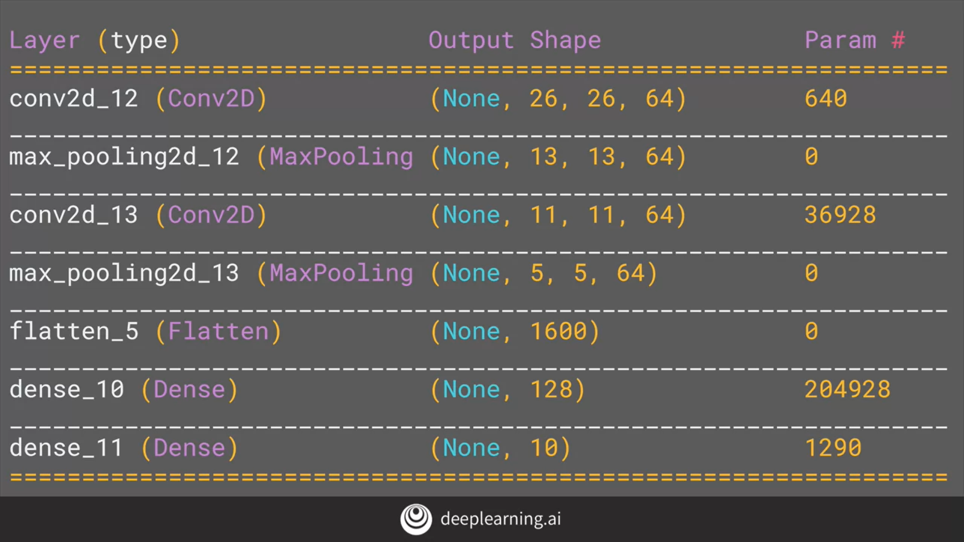

# Improving the Fashion classifier with convolutions

<https://colab.research.google.com/github/lmoroney/dlaicourse/blob/master/Course%201%20-%20Part%206%20-%20Lesson%202%20-%20Notebook.ipynb#scrollTo=C0tFgT1MMKi6>

# Walking through convolutions

<https://colab.research.google.com/github/lmoroney/dlaicourse/blob/master/Course%201%20-%20Part%206%20-%20Lesson%203%20-%20Notebook.ipynb>